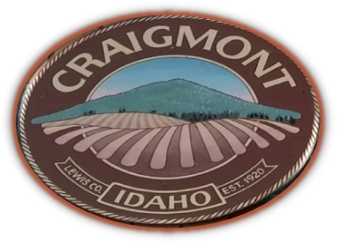
CITY OF CRAIGMONT

P.O. BOX 250
109 E. MAIN
CRAIGMONT, IDAHO 83523
Telephone (208) 924-5432

Craigmont City Council Meeting Agenda

February 4, 2025 7 P.M. City Hall

- CALL MEETING TO ORDER-ACTION
- APPROVAL OF MINUTES-ACTION
- ORDINANCE 455 REVIEW- ACTION
- CEDA –CARES GRANT – ACTION
- JUB/AIRPORT/LTGP/LRHIP/CARES -ACTION
- MERRICK & COMPANY/ SEWER– ACTION
- CARL DEVAULT SPECIAL USE PERMIT – ACTION
- WCPA EVENT – CATERING PERMIT - ACTION
- APPROVAL OF BILLS-ACTION

Mayor – Jared Arnzen
Commissioner of Public Utilities – David Osburn
Commissioner of Public Property – Kevin Brown
Commissioner of Public Protection – Shandrie Stigum
Commissioner of Public Works & ProTem President- Levi Bovey
Clerk/Treasurer – Laysn Berry
Assistant to the Clerk/Treasurer- JeAnn Willson
Maintenance Supervisor- Bob Samsel
Assistant Maintenance –

Executive Session-Idaho Code 74-206
Any person needing special accommodations to participate in the above noticed meeting should Contact the City of Craigmont at (208) 924-5432
AUDIO RECORDING MAY BE IN USE

Posted 01/31/2025

