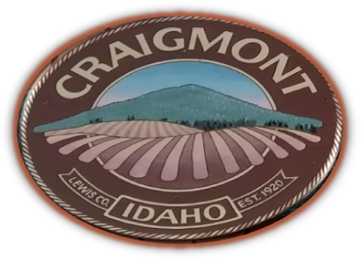
CITY OF CRAIGMONT

P.O. BOX 250
109 E. MAIN
CRAIGMONT, IDAHO 83523
Telephone (208) 924-5432 / Fax (208) 924-6801

CRAIGMONT CITY COUNCIL SPECIAL MEETING AGENDA

Friday June 21st
8 am Craigmont City Hall

Amendments
Final action cannot be taken on an item added to the agenda after the start of the meeting unless an emergency is declared that requires action at the meeting. The declaration and justification must be approved by motion of the Council.

- Council will address Alcohol Catering Permit Angie’s Country Kitchen - ACTION ITEM

Executive Session- Idaho Code 74-206- ACTION ITEM

Any person needing special accommodations to participate in the above noticed meeting should contact the City of Craigmont at 924-5432.

Posted 06/17/24

